**→Applications of Auto Encoders - Domain Adaptation :**

**(1) Import library’s and define size of images :**

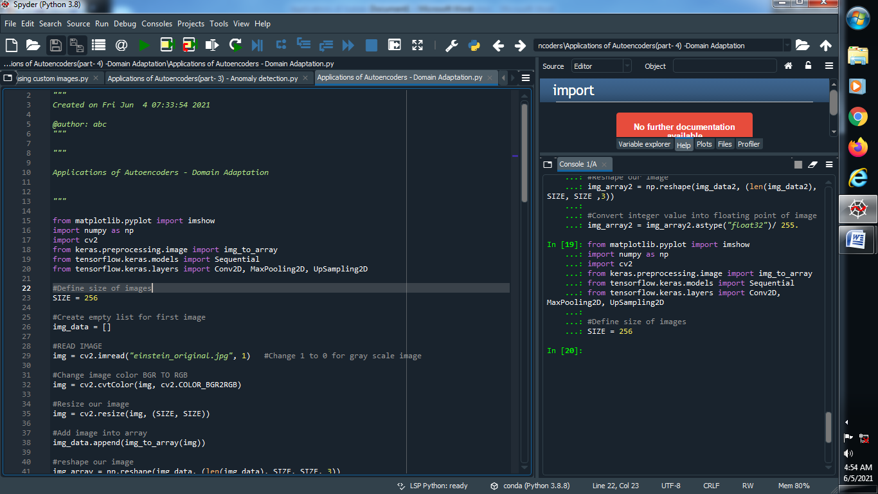

**(2) Create empty list for first image and read our image :**

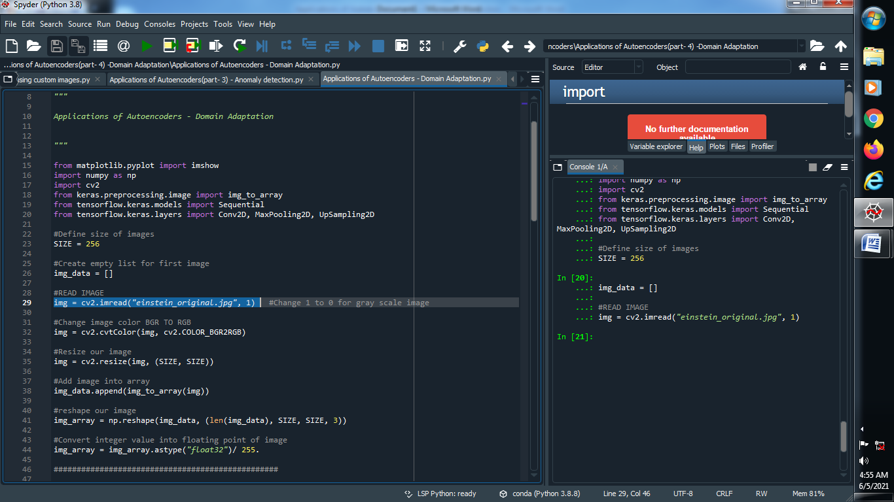

**(3) Change image color RGB TO BGR and resize this image :**

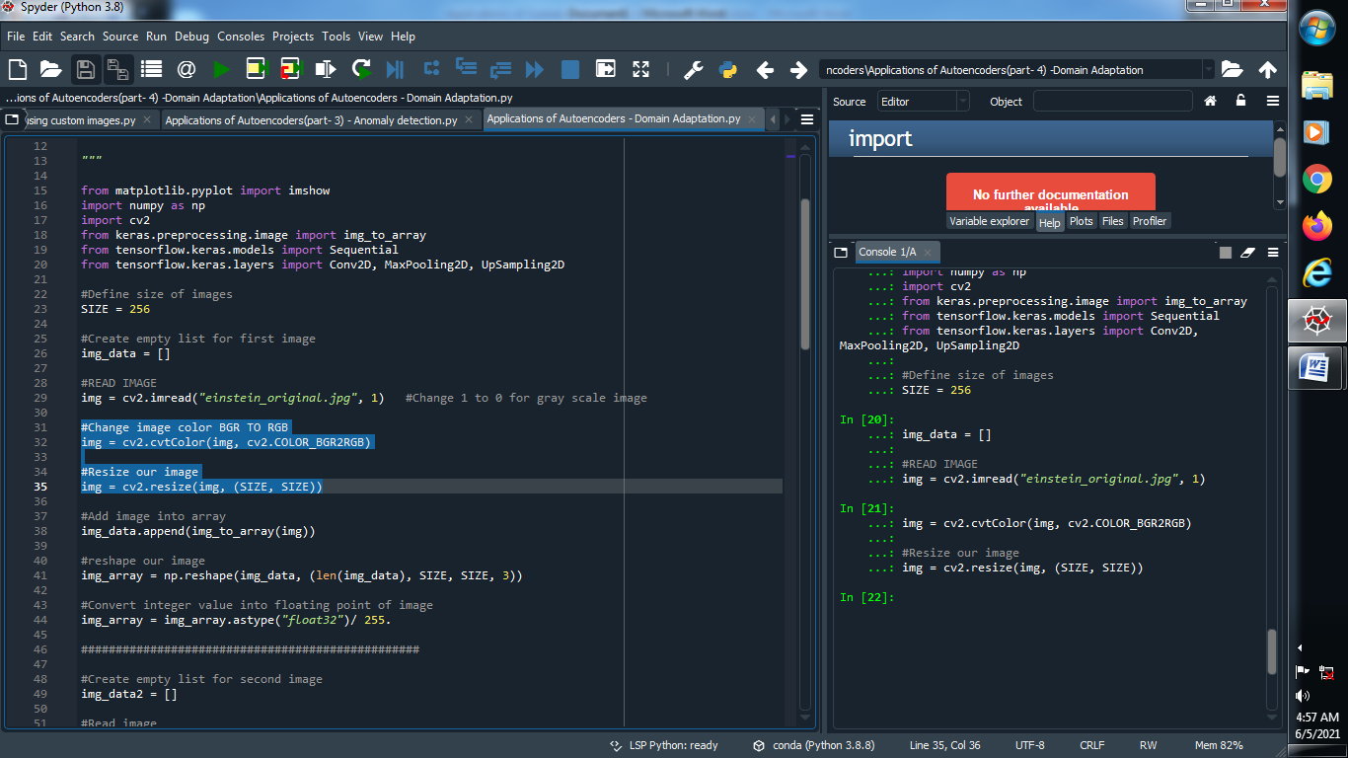

**(4) Convert image into array and reshape it :**

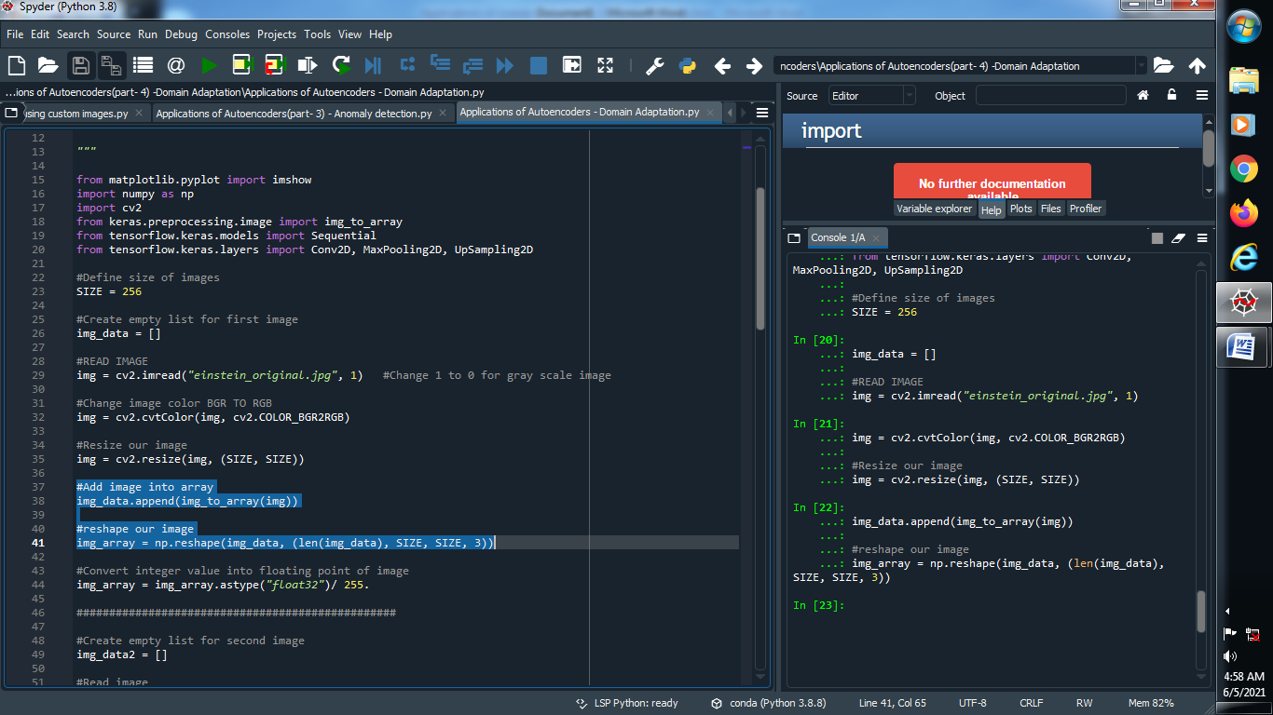

**(5) Convert integer value into floating point value of our image :**

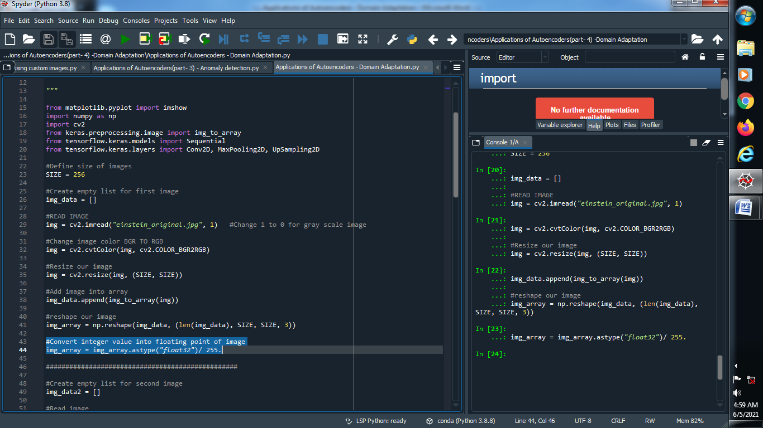

**(6) Fill the all same above things for our second image :**

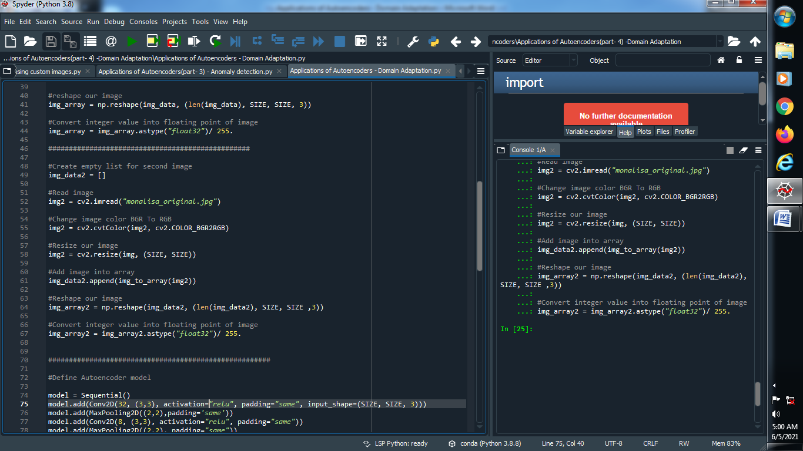

**(7) Define our auto encoder model :**

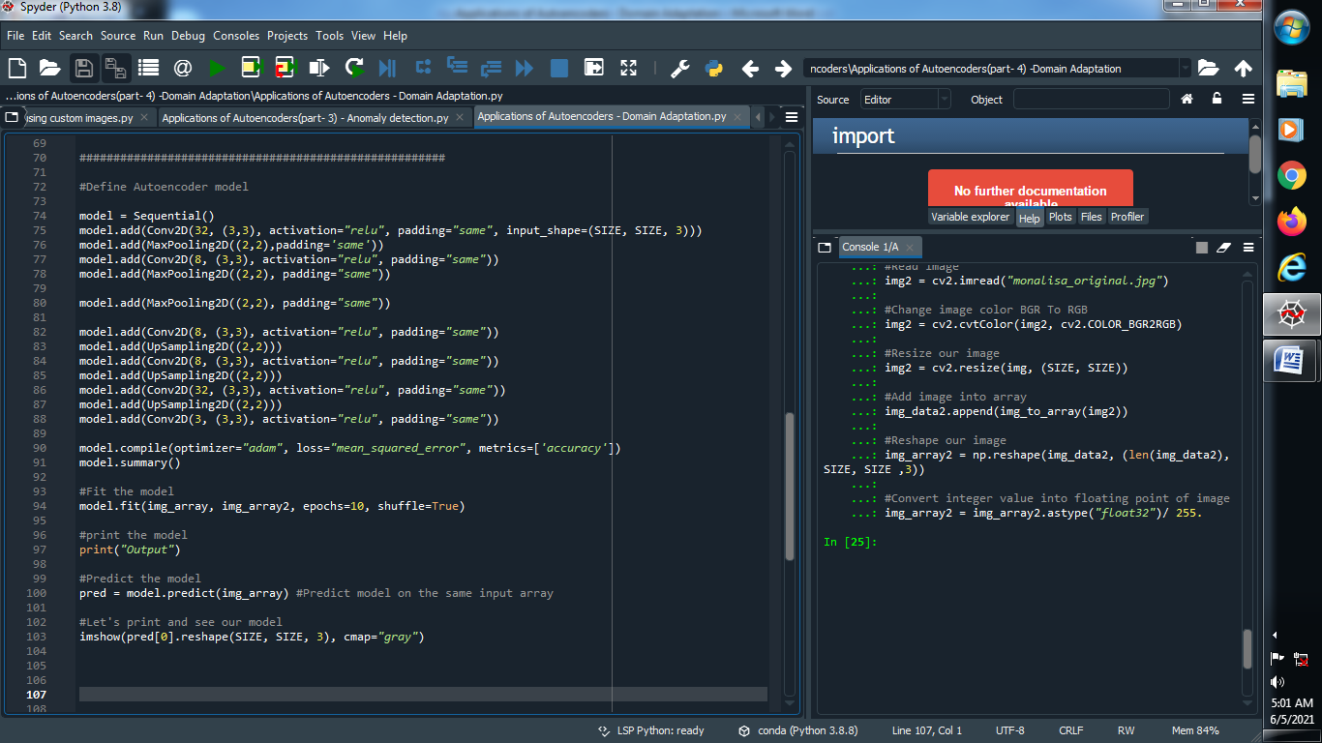

**(8) Fit the model :**

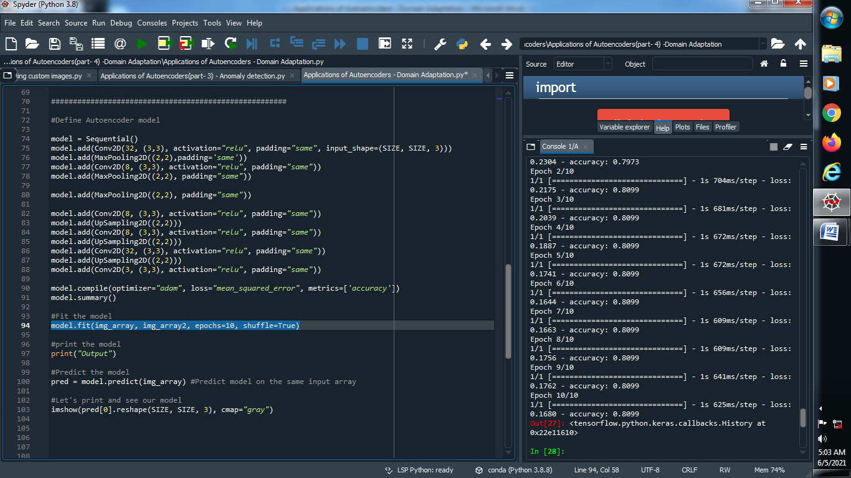

**Output :**



**(9) Predict our model :**

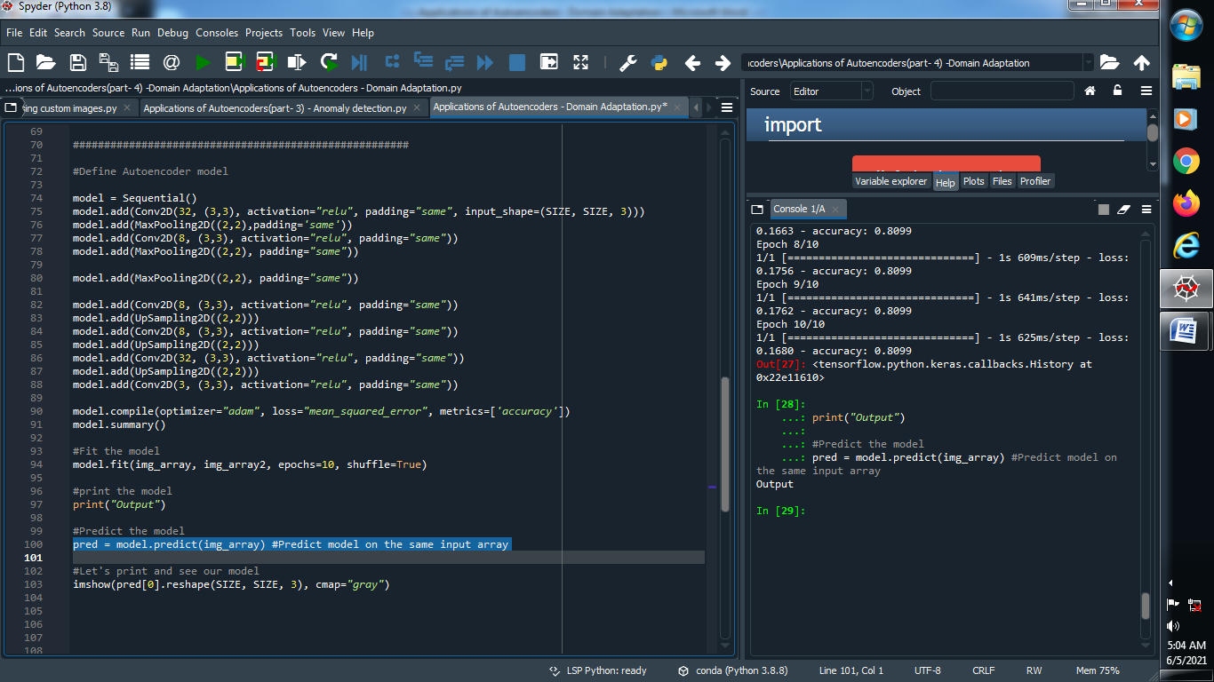

**(10) Let’s see our model :**

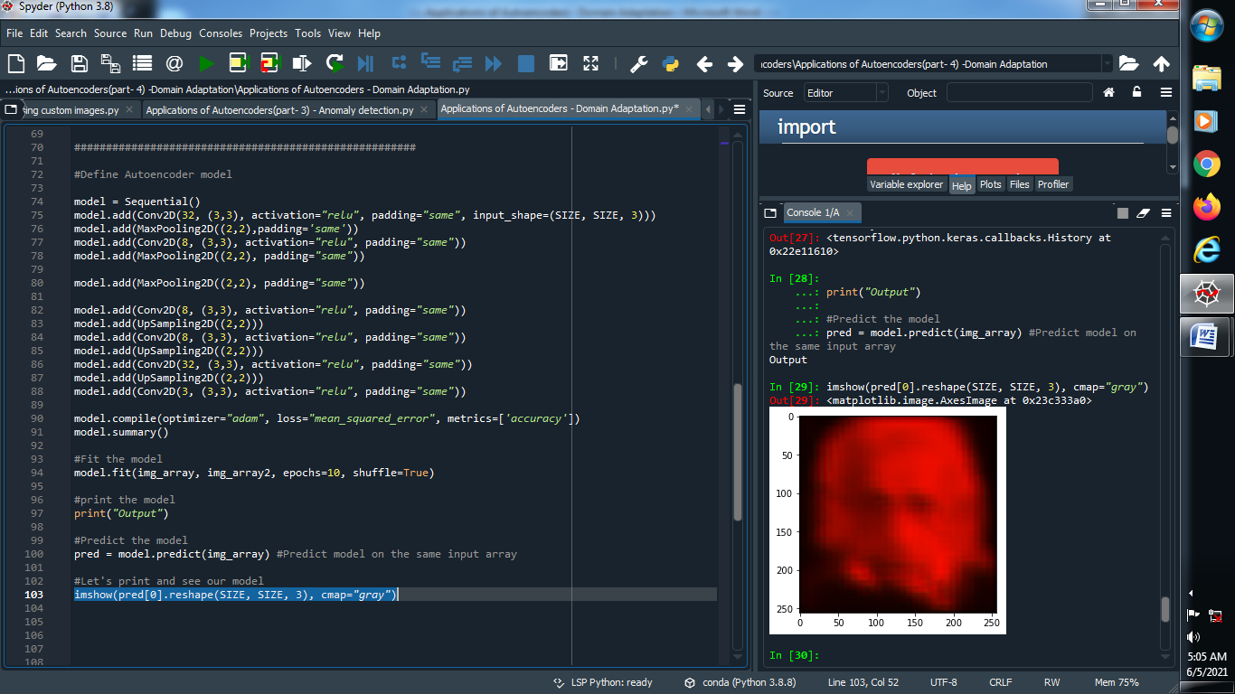

**Output :**

**→ Original first image : → Original second image :**

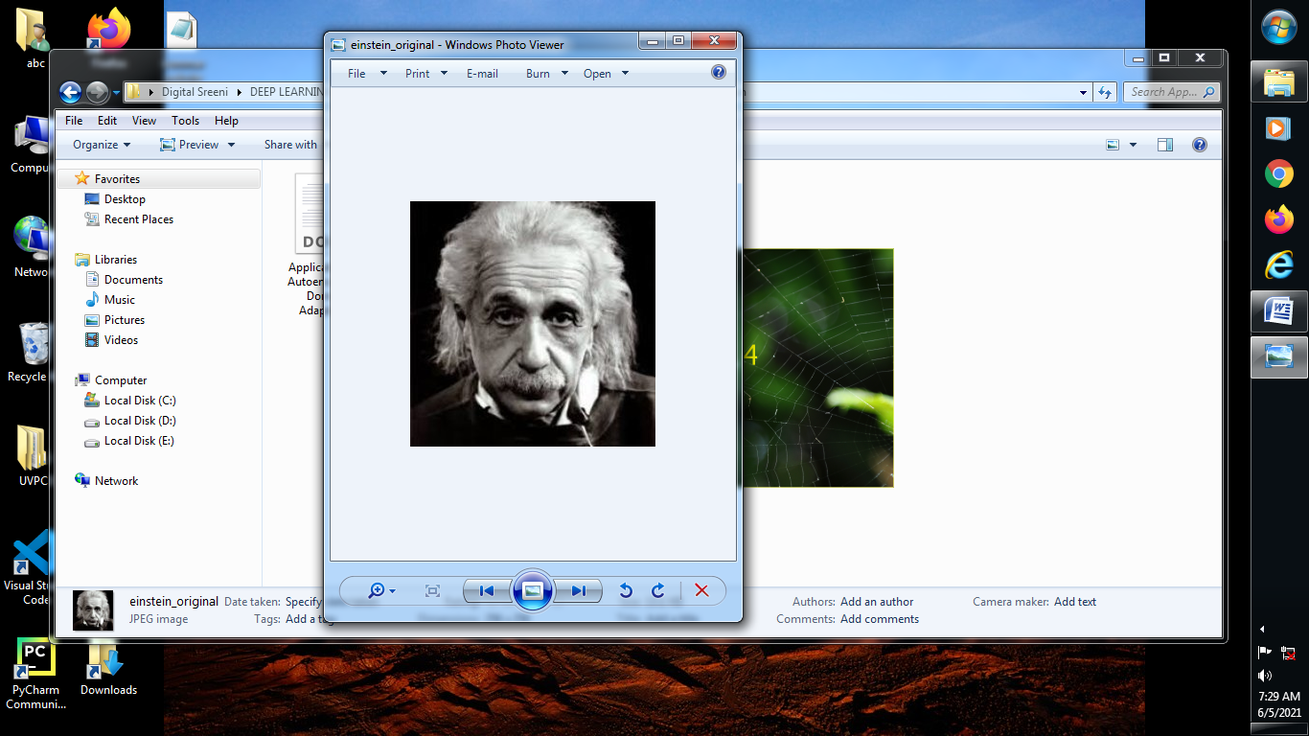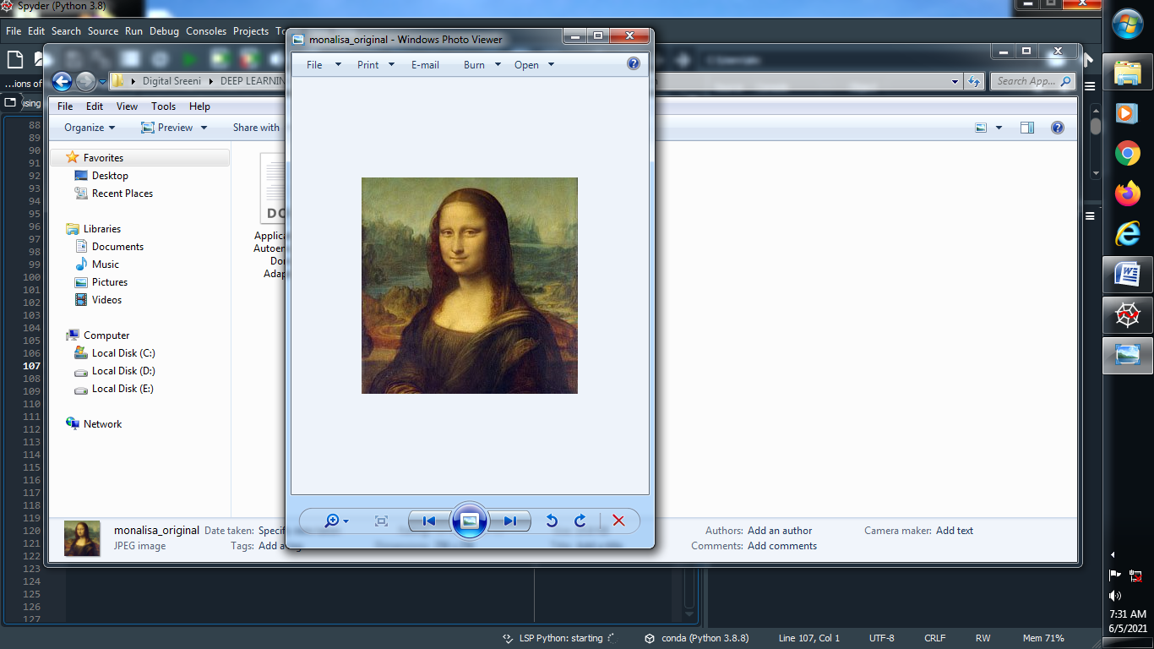

**→ Epochs = 10 → Epochs = 1000 → Epochs = 5000**

